Applied Machine Learning

ICS5110

Preliminaries
Student 1 Name: Emre Can
Student 2 Name: Conrad Aquilina
Student 3 name: Claudio Pisani
Git Hub Repository: https://github.com/C-Pisani/Applied_ML_Group_Project/

Abstract
Road traffic accidents remain of great concern in Malta, with far reaching consequences. The social, familial and economic impact is significant, and victims may sustain life-changing injuries. This paper applies traditional machine learning methods to analyse data extracted from police press releases. The extracted data includes dates, times, locations, vehicles and other accident-related variables. This data was subsequently enhanced with weather related information, in order to discover potential corelations and relationships between environmental conditions and the severity and number of road traffic accidents. Three different ML approaches were used to analyse the data and try to find patterns or provide predictions. These are Linear Regression, Support Vector Machine (SVM) and Random Forest. Initial results provide some useful insights but also highlight the issues associated with manual entry of reports. There are some inconsistencies in spelling, reports that have multiple accidents, and some other possible noise in the dataset. The total of 115 reports may be too small to gain meaningful insights and help determine any possible policy suggestion.

Contents
Preliminaries 1
Abstract 1
Introduction 3
Main Research Question 3
What factors extracted from the police press report may help predict the severity of traffic accidents in Malta? 3
Data 3
Data Source 3
Data extraction 4
Data Enhancement 4
Exploratory Data Analysis 5
Methodology 15
Random Forst 15

Introduction
Road Traffic accidents are a constant issue in Malta, due the large number of vehicles per square kilometre (density), the regular road obstacles and road works and the general state of some of the road infrastructure. Understanding the variables that contribute to accidents and the severity of incidents can help authorities take preventive measures or plan targeted measures.
The dataset provided is an unstructured text format, that may contain valuable contextual information that may not be fully utilised. If structured police reports exist, this exercise may be used to augment other findings carried out through some other process.
The main objective of this project is to apply machine learning algorithms to the data that is extracted from these press releases.
The primary aims are:
- Extract structured data from unstructured press reports
- Extricate data features such as temporal data and contextual variables such as injuries, vehicles, location and others
- Evaluate traditional ML techniques to for predicting accident severity
- Assess any ethical analysis, to identify bias such as location or weather conditions
Main Research Question
What factors extracted from the police press report may help predict the severity of traffic accidents in Malta?

Related work
Some work has been done locally to try and predict the severity of traffic accidents as can be seen in [1]. On a different note, another study tried to understand the dynamics of road injury with the aim of increasing the safety of pedestrians [1].
Other studies also look at accident severity in different countries such as Thailand [2] and Australia with an emphasis on class imbalance [3]. A large-scale dataset ML approach, with over 2 million records that also looked temporal and climatic conditions [4]. This study added another factor that may be of interest in future studies. This is the vehicle age.

Data

Data Source
The primary data that was used in this study is the Police Press report, as was provided to us. Each report typically reports the date the report was publish, the time the locality, the vehicles involved and the severity of injuries sustained. In some cases, multiple accidents are reported in one press report.
While skimming through the local news articles, there was no immediate corelation between the police press report and the news articles. As such it was decided to extract relevant metrics from the police report.

Data extraction
From the unstructured text, the following attributes were extract using a mix of Natural Language processing, regex pattern detection and text parsing
- Fatalities mentioned
- Fatalities Count
- Vehicles
- Accident Types
- Hospital
- Injuries
- Brands (of vehicles)
- Day. The day of the week.
- Time. The reports use a quarter-hour reporting
- Age
- Road
- Town
- Location

The following are some observations and comments on the data extracted.
- Vehicles. These include cars, motorcycles, scooters and others. If a person was hit, a “pedestrian” is added.
- Accident Types. This is mostly to determine the terminology used. It is not used in data model. This may be used to improve consistency.
- Hospital. The initial idea was to use determine if the accident happened in Malta or Gozo. Not used in any model but could be useful for later scenarios. For example, what would happen in case of another pandemic.
- Injuries. The type of injuries, such as Grievous, Serious and others. So spelling inconsistencies have been observed and multiple occurrences have also been noted.
- Brands (of vehicles). In some cases, the Brand of a vehicle is listed instead of car/ scooter
- Time. The reports use a quarter-hour reporting.
- Age. Due to the unstructured nature of the report, the age may refer to the driver or the victim.
- Road and town are extracted from Location. The list of locations was obtained from [5].

Data Enhancement
Using the town and the geopy [6] library, the longitude and latitude where derived. These values were derived once per town. These data points were then used to get the weather data using the openmeteo package [7] and the co-ordinates and date as parameters. The weather data closest to the time of the accident is added to the dataset.

Exploratory Data Analysis
The exploratory analysis starts off parsing the string data extracted into data types that are easy to work with. This preprocessing step is required since the text is not computationally friendly and helps turn ambiguous strings into a structured format that is ML friendly.
Following the data preprocessing, several exploratory graphs are created to visualise the data.
Accidents per Day of Week
The days with the greatest number of accidents are Thursday and Sunday.

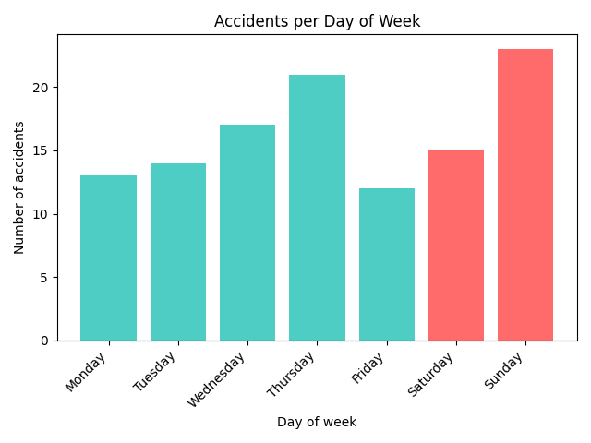

Accidents by Hour
The accidents are spread out throughout most of the day. What stands out is a lack of reports at 03:00, and a sharp increase around rush hour traffic.

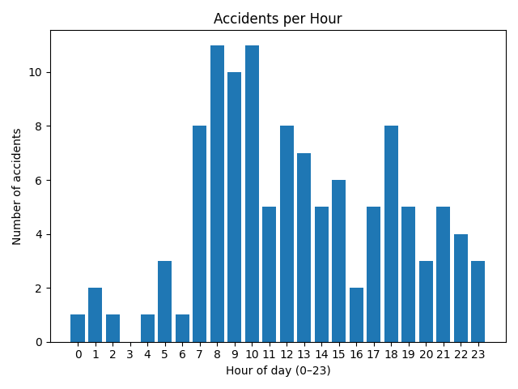

Accidents per month
This graph bounces around quite a bit. There is a spike in February, which has the highest, followed by a sharp drop in March. This may need to be investigated further.

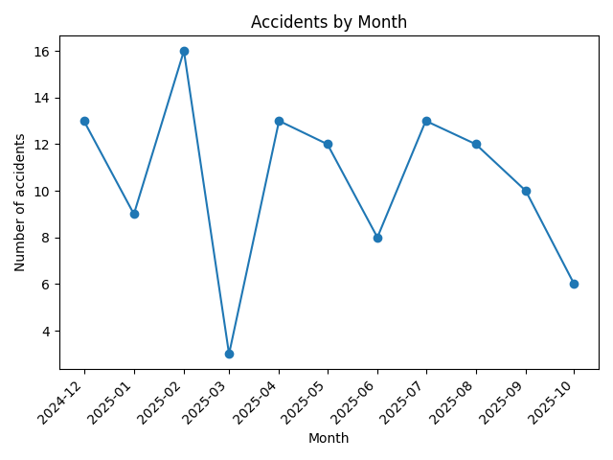

Age Distribution of drivers

This graph shows a broad distribution across the different age groups with very few younger drivers. This could mean that the new driving training is improving, there is less driver participation in this age group, or the tracking systems that are provided by insurance companies may be contributing to the decrease see [8] and [9]. Whatever the cause may be, this could do with some more investigation

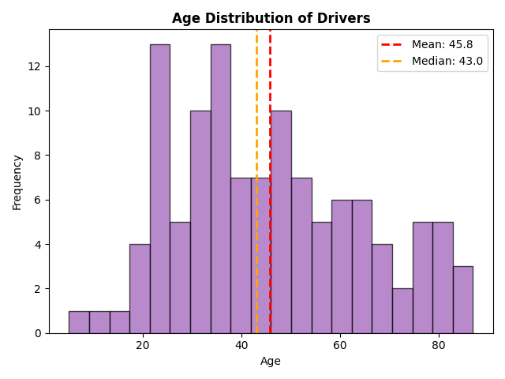

Injury Severity Distribution
An accident can involve one or more persons. As such, the report may contain multiple injuries that relate to different people. The data is also heavily skewed towards Grievous injuries. This could indicate that the police are mostly called in when people are injured. The spelling inconsistencies also make this data more prone the inconsistencies.

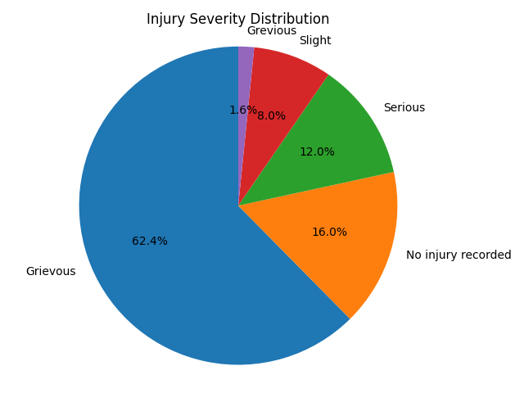

Fatalities per hour
The distribution of fatalities is quite random. This is one area that could have been enhanced with the inclusion of the news articles. However, the following should be taken into consideration.
- A person may have eventually passed away due to the injuries sustained.
- The time between the two events may be considerable.
- The cause of death may not necessarily be the accident itself, but could be due to an underlying condition.
As such, this graph only indicates people who have passed at the scene of the accident.

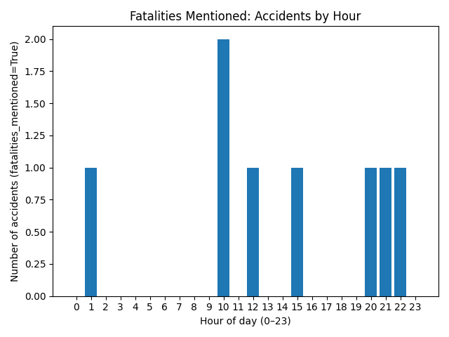

Proportion of Cars, motorcycles and pedestrians
This graph shows the number of cars, motorcycles and pedestrian involved in accidents.

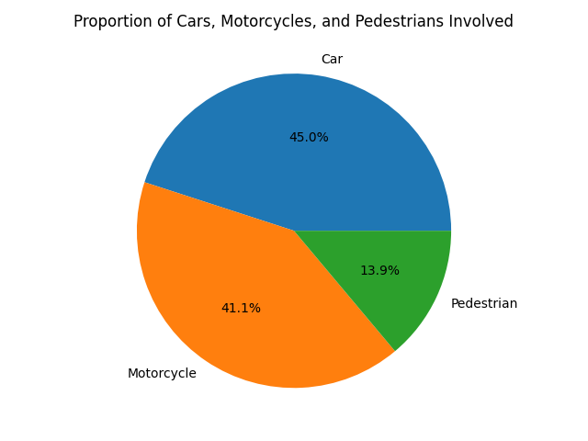

Accidents by Visibility
The data tends to show more accidents happen with better visibility. This may indicate that people may be more careful when the visibility is not so great. Another reason could be that people may avoid driving when the visibility isn’t very good.

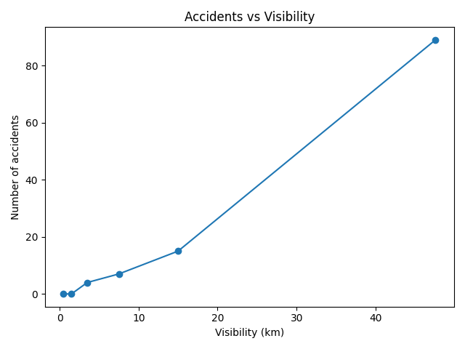

Accidents by Rainfall
Similar to visibility, the data seems to indicate that people may be more careful when it is raining. Some people also don’t like taking their car out in the rain.

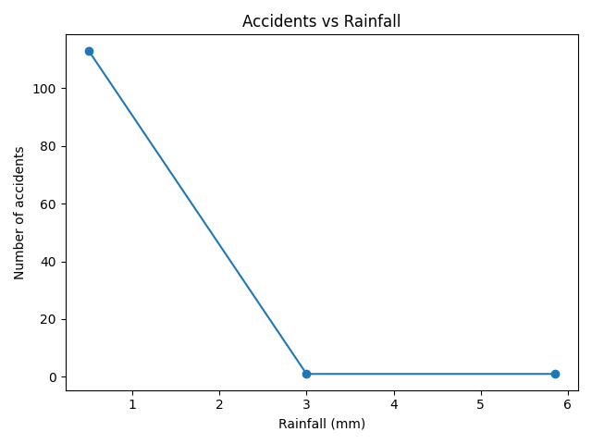

Accidents by Town
The data shows that the town with most accidents is Naxxar.

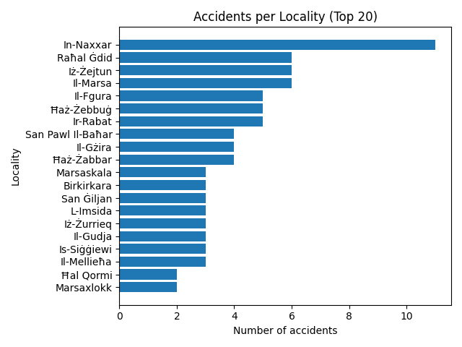

Methodology

Random Forest
This objective of this study is to use a supervised learning approach using traffic accident data and to try and predict the accident-related outcomes based on temporal and contextual features extracted from the police press reports. The data has also been enhanced with weather data.
Random forest is a good model for this data, since it handles many features and can handle noise, such as in the injuries, and outliers. Each tree has a vote that can help to reduce overfitting when compared to a single tree.
This was implemented as a classification problem, to try and predict specific characteristics such as accident severity.
The feature importance for the Random forest is shown below. These are impurity-based using Gini impurity.
feature | importance |  | feature | importance
age | 0.117540 |  | has_car | 0.016350
hourly_visibility_km | 0.100229 |  | is_weekend | 0.016093
town_encoded | 0.098259 |  | has_pedestrian | 0.012117
age_group_encoded | 0.092948 |  | daily_rain_sum | 0.001391
hour | 0.089008 |  | has_precipitation | 0.001254
day_encoded | 0.082399 |  | very_low_visibility | 0.001210
month_num | 0.074529 |  | has_precipitation | 0.001192
time_period_encoded | 0.059753 |  | has_rain | 0.001139
low_visibility | 0.036250 |  | hourly_showers | 0.001019
num_vehicles | 0.036051 |  | hourly_precipitation | 0.001013
has_van | 0.032741 |  | has_bike | 0.000396
weather_encoded | 0.025795 |  | has_rain | 0.000304
is_rush_hour | 0.022056 |  | hourly_rain | 0
has_motorcycle | 0.020777 |  | has_bus | 0
is_collision | 0.020322 |  | has_truck | 0
is_night | 0.019116 |  | has_scooter | 0
has_vehicle | 0.018747

This data captures predictive usefulness and not causality. Demographics such as age and age_group_encoded (ages in bins) are both near the top. The time and day also have a strong signal as well as the month. These could indicate traffic pattern, such as is_rush_hour, is_night and is_weekend. Although these values are lower, they are not insignificant. Another aspect that can be derived from the above data, is that the report possibly classifies scooters and bikes with motorcycles, which may signify consistency in this case. Weather variables are quite weak, indicating that drivers may be more careful when driving in inclement weather.
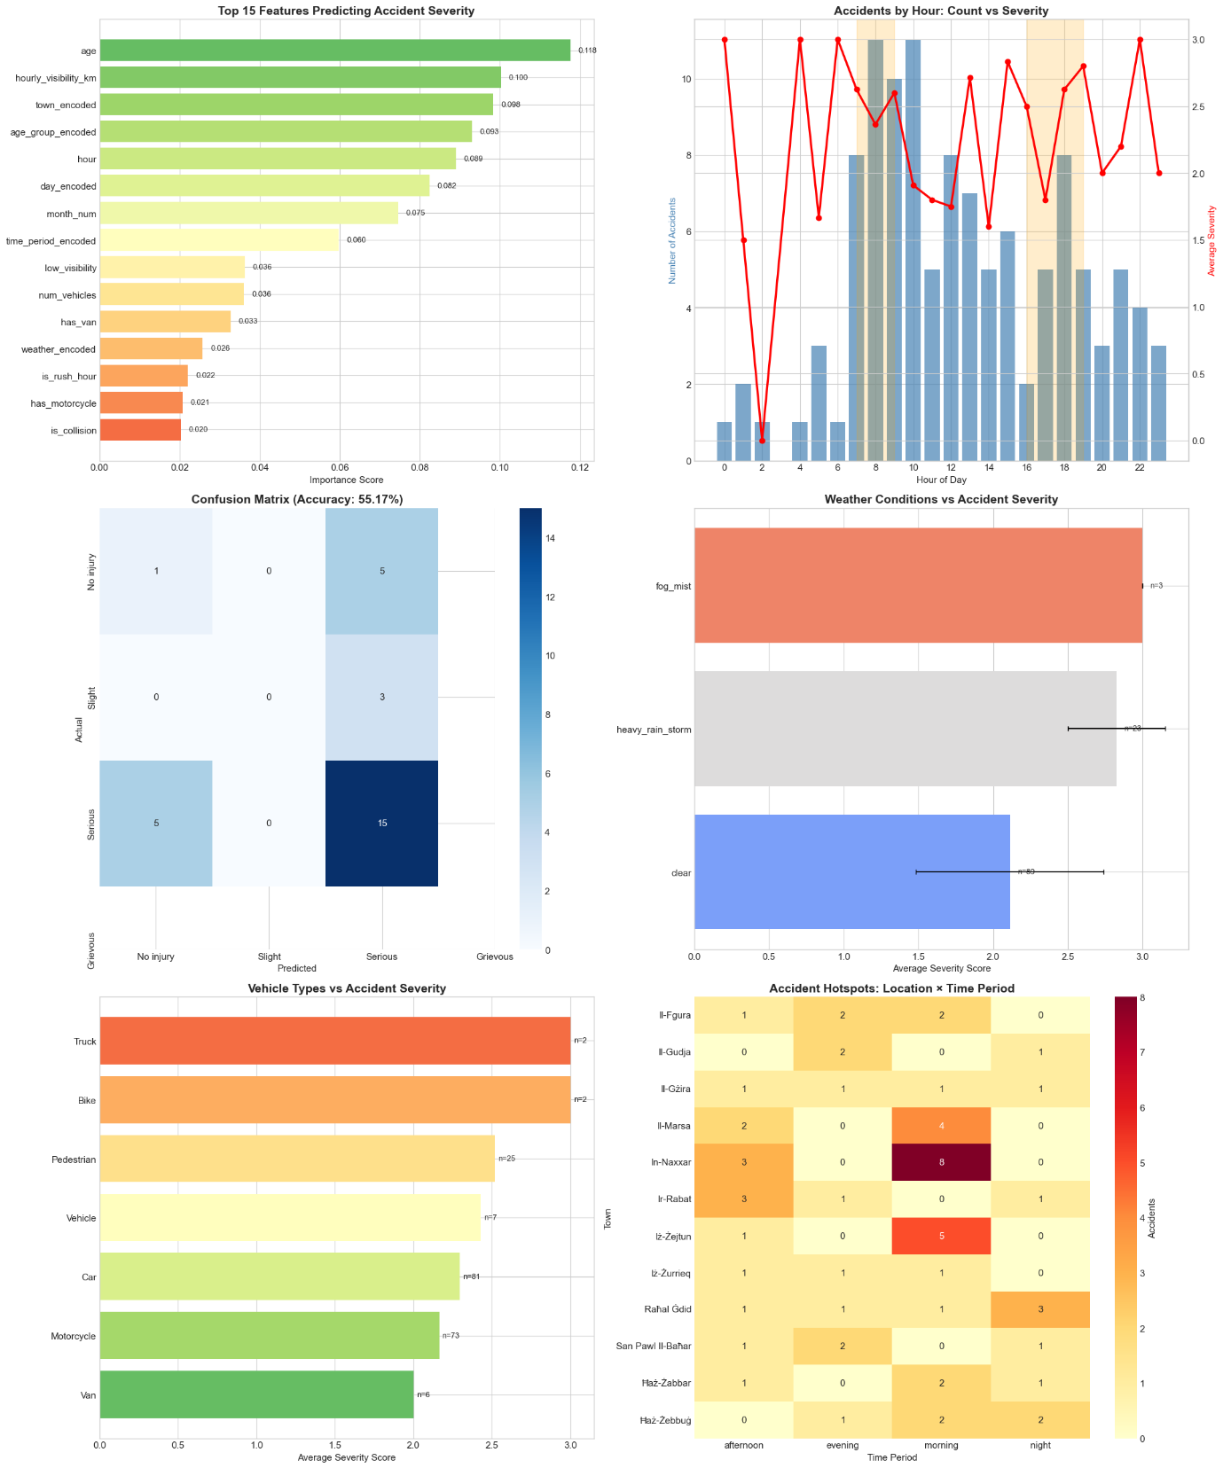

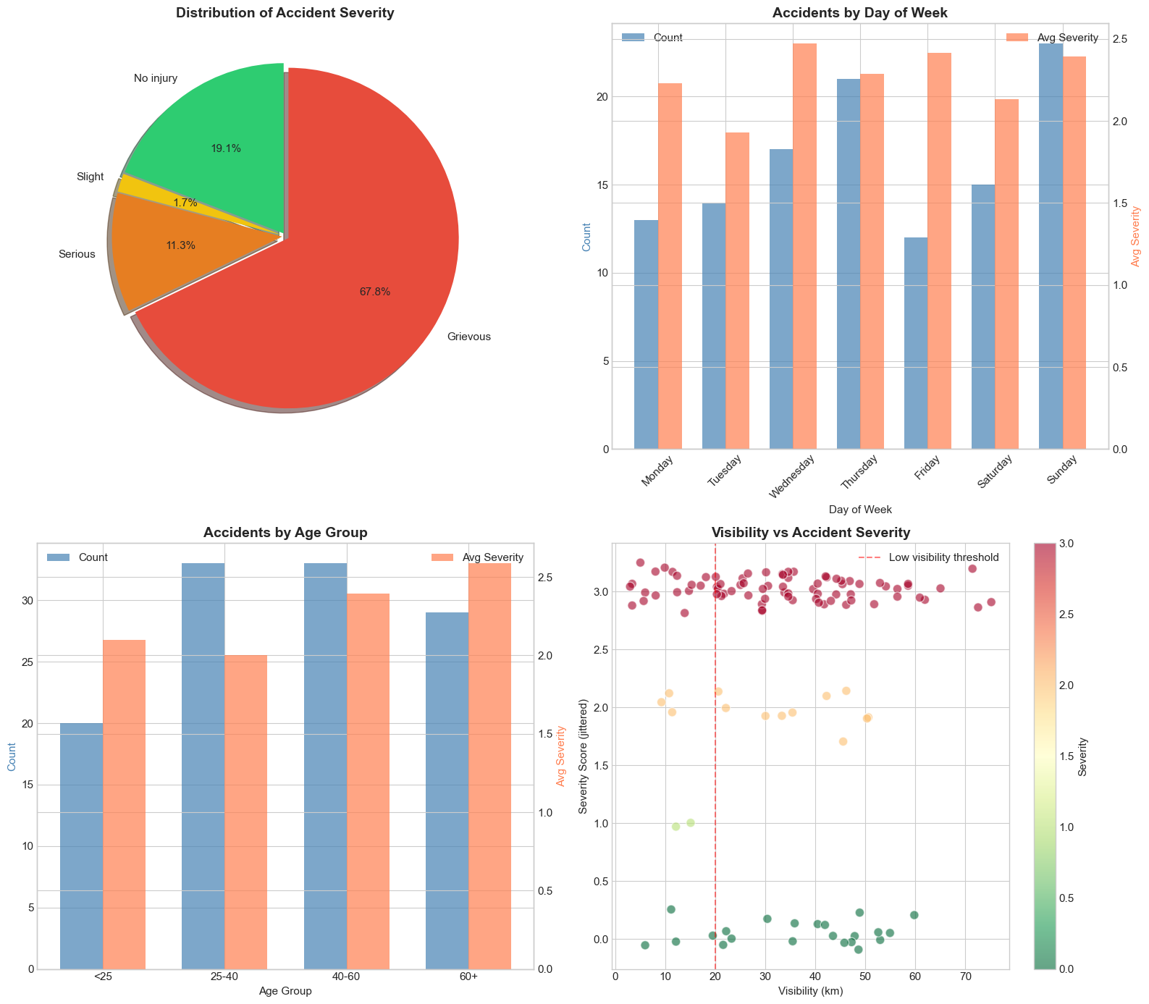

Support Vector Machines
Support Vector Machines (SVMs) are supervised learning algorithms utilized for classification and regression tasks. The fundamental objective of an SVM is to identify the optimal separating hyperplane that maximizes the margin between different classes within the feature space. When data is not linearly separable, kernel functions are employed to map the original input space into a higher-dimensional feature space, where a linear separation becomes feasible. In this project, the Radial Basis Function (RBF) kernel was selected, which is capable of handling non-linear relationships between class labels and attributes. The regularization parameter, C, and the kernel coefficient, gamma, are critical hyperparameters that determine the trade-off between maximizing the margin and minimizing the classification error on the training data.

Problem Formulation
The objective of this analysis was defined as the binary classification of traffic accident severity. Specifically, the model was tasked with predicting whether an accident resulted in a "grievous" injury based on a set of environmental and operational features. The target variable, is_grievous, was derived from the dataset, where accidents were categorized by severity levels. The dataset utilized for this research comprises records of traffic incidents in Malta, encompassing attributes such as location coordinates (latitude, longitude), temporal data (hour, day, month, year), weather conditions (temperature, precipitation, wind speed, visibility), and vehicle characteristics (presence of motorcycles, cars, vans, and pedestrians).
Prior to modelling, the data was pre-processed to ensure suitability for the SVM algorithm. Non-numerical and textual columns, including specific road names, towns, and raw descriptions of accident types, were excluded from the feature set to focus on quantitative and categorical indicators. The dataset was partitioned into a training set, comprising 88 samples, and a test set, comprising 23 samples, maintaining a stratification based on the target variable to preserve class distribution. Numerical features were standardized using a standard scaler to ensure that features with larger magnitudes did not disproportionately influence the distance calculations inherent to SVMs.

Evaluation Metrics
To assess the efficacy of the classification model, several metrics were employed. Accuracy was used to measure the overall proportion of correct predictions. However, given the potential for class imbalance in accident data, reliance solely on accuracy would be insufficient. Therefore, precision and recall were calculated to evaluate the model's exactness and completeness, respectively. The F1-score, the harmonic mean of precision and recall, was utilized to provide a balanced view of the model's performance on the minority class. Additionally, the Receiver Operating Characteristic Area Under the Curve (ROC AUC) was computed to determine the model's ability to distinguish between the two classes across different threshold settings. Cohen’s Kappa and the Matthews Correlation Coefficient (MCC) were also included to account for chance agreement and to provide a robust measure of quality for binary classifications.

Analysis of Model Performance
A hyperparameter tuning process was conducted using GridSearchCV with 5-fold cross-validation to identify the optimal configuration for the SVM. The parameter grid search explored various values for C (0.1, 1, 10, 100, 1000), gamma (1, 0.1, 0.01, 0.001, 0.0001), and different kernel types including linear, RBF, and sigmoid. The best-performing model was identified with a C value of 100, a gamma of 0.001, and an RBF kernel, achieving a best cross-validation score of 0.7163.
Upon evaluation on the test set, the model demonstrated a discrepancy between training and testing performance. A training accuracy of 0.8182 was recorded, whereas the test accuracy dropped to 0.6522. This gap suggests that overfitting occurred, where the model learned the noise in the training data rather than the underlying generalizable patterns. The ROC AUC score was found to be 0.5446, indicating that the model’s ability to rank positive instances higher than negative ones is only marginally better than random chance.
Furthermore, the classification report revealed significant issues with class balance handling. For class 1 (likely the grievous injury class), a precision of 0.70 and a recall of 0.88 were achieved, resulting in an F1-score of 0.78. In contrast, class 0 exhibited a poor recall of 0.14 and a precision of 0.33. This indicates that the model is heavily biased towards predicting grievous injuries and fails to correctly identify non-grievous incidents. The low Cohen’s Kappa (0.0213) and MCC (0.0244) scores further reinforce the conclusion that the model’s predictive power is limited and heavily influenced by the class distribution.

Key Insights
Several insights are derived from the results. First, the selection of a high C value (100) during the grid search implies that a complex decision boundary was preferred to minimize training error, which likely contributed to the observed overfitting given the small sample size (only 88 training instances). The dataset size is identified as a critical bottleneck; with fewer than 120 total records, the SVM lacks sufficient examples to establish a separation margin that generalizes well to unseen data.
Second, the disparity in recall between the two classes highlights the challenge of imbalanced datasets in accident analysis. It is observed that the model defaults to predicting the majority class (grievous injuries in the test split), maximizing overall accuracy at the expense of minority class detection. The extremely low recall for class 0 suggests that the features provided—such as weather and vehicle type—may not contain sufficient signal to clearly differentiate non-grievous accidents under the current model configuration.
Ethical Considerations
When deploying machine learning models for public safety and accident analysis, ethical implications must be scrutinized. One primary concern is the potential for bias encoded within the training data. If the dataset disproportionately represents certain geographic locations or vehicle types due to reporting practices, the model’s predictions could unfairly penalize specific demographics or areas, leading to skewed resource allocation by emergency services or insurance adjustments.
Privacy is another significant consideration. Although the data appears to be aggregated, the inclusion of precise timestamps and location coordinates raises the risk of re-identification of individuals involved in specific accidents. It must be ensured that such data is anonymized effectively before being used for automated decision-making. Furthermore, the "black box" nature of non-linear SVMs (specifically with RBF kernels) presents a challenge for transparency. In contexts involving legal or medical consequences, the inability to easily explain why a specific accident was classified as grievous could undermine trust in the system. Accountability mechanisms must be established to ensure that algorithmic predictions support, rather than replace, human judgment in critical safety assessments.

IV. Multiple Linear Regression

The implementation of the predictive model focused on identifying linear relationships between meteorological variables and daily traffic accidents. The process involved three distinct stages.

1. Data Preprocessing and Aggregation

The expanded dataset was utilized to create a daily time-series. Timestamps from the date_published column were truncated to a date-only format. Records were then grouped by date to calculate the daily accident frequency and the mean of the hourly weather observations. This transformed the data into a format suitable for regression, where the target variable is the daily accident count.

2. Feature Engineering and Scaling

Four primary features were selected: hourly_temperature_2m, hourly_precipitation, hourly_windspeed_10m, and visibility_km (derived from hourly_visibility). To ensure numerical stability and prevent features with larger ranges from dominating the model, a StandardScaler was applied. This normalized the features to a mean of 0 and a standard deviation of 1, allowing for a direct comparison of the resulting coefficients.

3. Model Training

The dataset was split into a training set (80%) and a testing set (20%) using a fixed random seed for reproducibility. A Multiple Linear Regression model was fitted using the Ordinary Least Squares (OLS) method to establish the weights for each weather factor.

V. Results

Regression Performance and Feature Importance

The Multiple Linear Regression model achieved an R² score of -2.6250 and a Mean Squared Error (MSE) of 0.7272. A negative R² score indicates that the model's predictions, on this specific test set, were less accurate than simply predicting the average number of accidents every day.

The relative influence of each feature was determined through the analysis of Scaled Coefficients:

- Hourly Precipitation: +0.3207

- Hourly Temperature: -0.1067

- Visibility: -0.0407

- Hourly Wind Speed: -0.0249

Discussion of Findings

The negative R² score and the high coefficient for Precipitation (+0.3207) reveal a significant characteristic of the dataset: Sensitivity to Outliers.

- The Precipitation Over-Response: The model assigned a high positive weight to precipitation, expecting accidents to increase significantly with rain. However, on the day with the highest recorded rainfall in the dataset (January 16th), only one accident was recorded. The model predicted over 4 accidents for that day, and this large error on a small test set caused the R2 to become negative.

- The "Careful Driver" Hypothesis: In Malta, extreme weather (high precipitation) may not result in a linear increase in accidents. Drivers may choose to stay home or drive with extreme caution, which contradicts the "Linear" assumption of this model. This explains why the model's "logic" failed when faced with extreme rain.

- Temperature and Visibility: Temperature showed a negative correlation (-0.1067), suggesting a slight increase in accidents during colder periods. Visibility showed a negligible negative impact, reinforcing the idea that clarity alone is not a primary driver of daily accident counts.
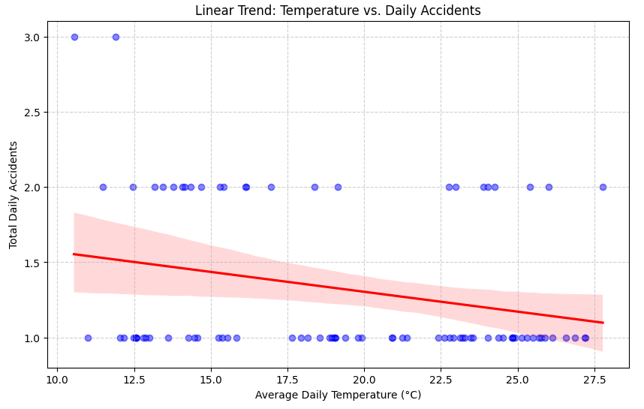
Fig.1

Figure 1 illustrates the linear relationship between temperature and accident frequency. The downward slope of the regression line aligns with the negative coefficient (-0.1067) identified by the model. This confirms a trend where accident frequency slightly increases as temperatures decrease, though the high density of data points around 1 and 2 accidents suggests that temperature alone remains a secondary factor.

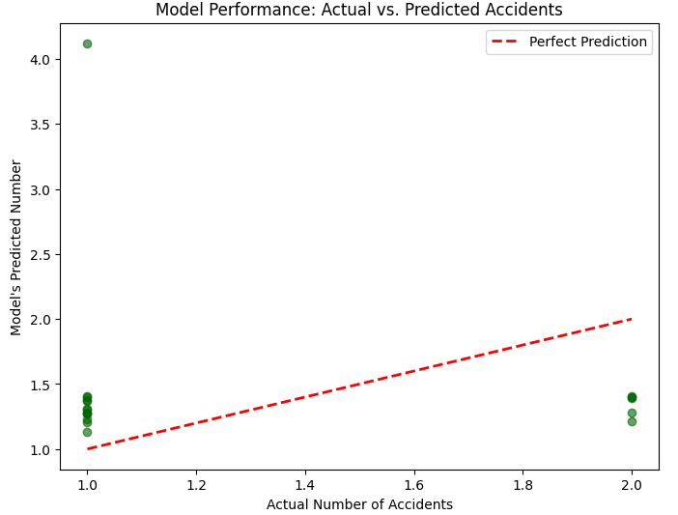
Fig.2

Figure 2 compares the model's predictions against the actual observed values. The high dispersion of points and their lack of alignment with the identity line (red dashed line) visually demonstrate the negative R² score of -2.6250. This chart specifically highlights the model’s tendency to over-predict accident counts on extreme weather days (outliers), where the predicted values are significantly higher than the actual recorded incidents.

In conclusion, the R² of -2.625 demonstrates that daily traffic accidents in Malta are highly "stochastic" (random) and influenced by non-linear human behaviors that a simple linear model cannot fully capture, especially when dealing with extreme weather outliers, and a very limited dataset.

